*Florida International University*

*School of Computing and Information Sciences*

CIS 4911 - Senior Capstone Project

Software Engineering Focus

Feature Document

User Story #1031

**Team Member:**

Michael Martinez

**Product Owner(s)**:

Mohsen Taheri

**Mentor(s)**:

Mohsen Taheri

**Instructor**:

Mohsen Taheri

**User Story** View Recent History Feature

**Description**

As a VIP CO-PI/PI/Faculty, I would like to see my history for the review pages so I can change my mind later or look at the history of actions.

**Acceptance Criteria**

1. Add an Recent History table below the review table.
2. Each record in recent history has an undo button.
3. Implement this for Review Student Applications and Review Project Proposals

**Use Case**

1. Participating Actors: Co-Pi/Pi and Faculty & Staff  
   Entry Condition: Must be on any of the review pages(Review Student applications page or Review Project Proposal)  
   Events Flow:
2. Can undo an approved project or approved application
3. Can undo a rejected project or rejected application

**Use Case Diagram**

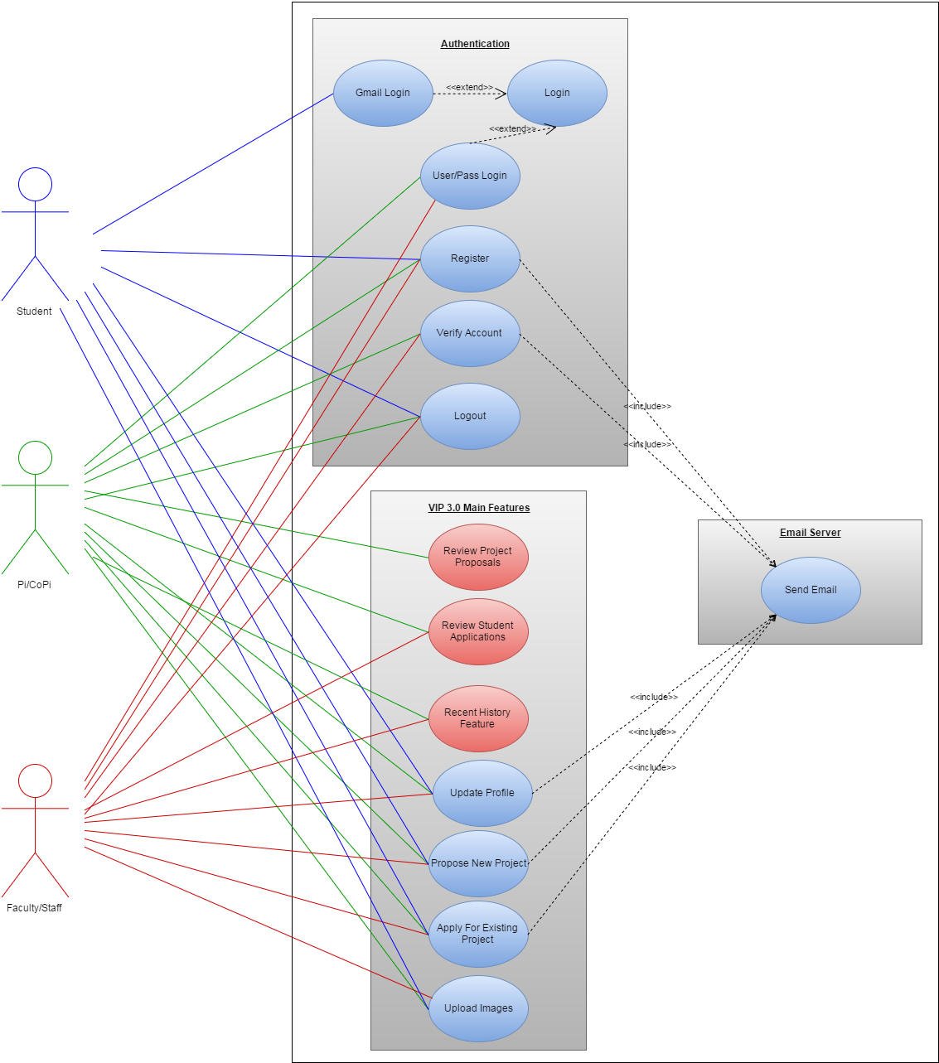

**Sequence Diagram**

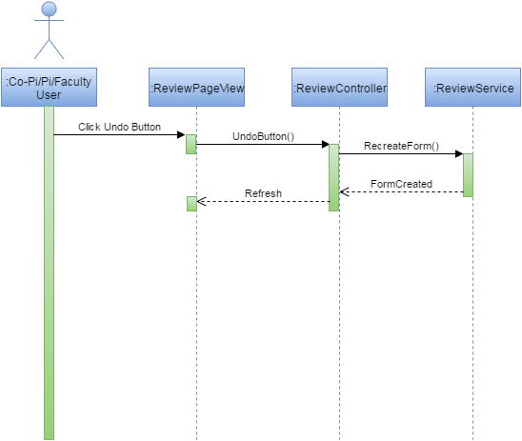

**Class Diagram**

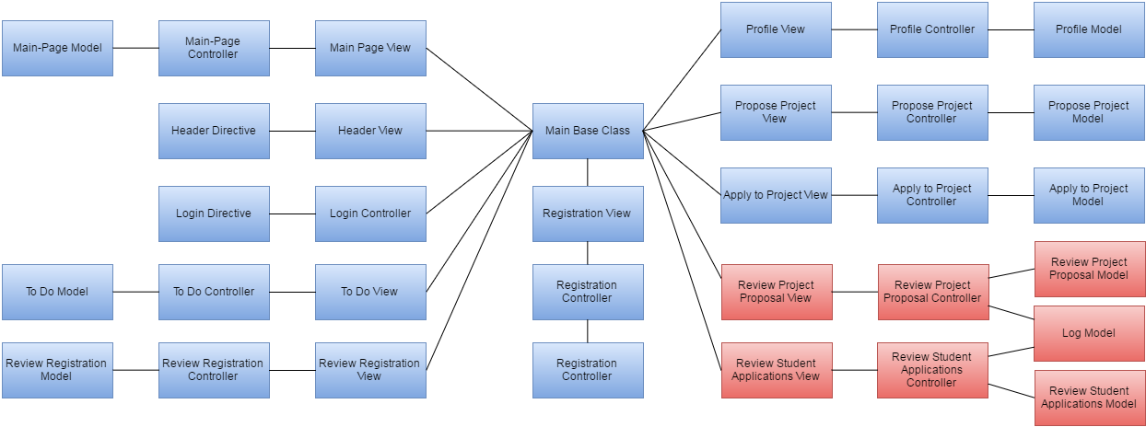

**Unit Test & Integration Test**

**Test Case 1**:

**Purpose**: Test that Undo will recreate the Student Application/Project Proposal and delete the log file.

**Precondition**: There must already be a log of the Student Application/Project Proposal

**Input:** Click on Undo Button

**Expected Result**: The log will be deleted and a Student Application/Project Proposal with the same information on the log will be created.

**Actual Result**: Same as expected.

**Test Case 2**:

**Purpose**: Test that a Log is created after approving/rejecting a project/student application

**Precondition**: A user must have already sent a project proposal or student application

**Input:** Click on approve or reject button.

**Expected Result**: Log is created

**Actual Result**: Same as expected.

**Visual User Guide**

